WHAT EUROPE?

A survey carried out by Obchodní akademie Karviná, s.r.o (Czech Republic)

The students of the Class 2 carried out a sociological research „Searching for an ideal school“. The questions and results and divided into three sections:

I. General questions
II. Questions about school
III. Questions about school subjects

38 students of our school, Obchodní akademie in Karviná, participated in the research. Out of them there were 14 students of the Class 1, 9 students of the Class 2, 8 students of the Class 3 and 7 students of the Class 4

I. GENERAL QUESTIONS

1. Rate the Czech educational system (1 = excellent….. 5 = very bad)

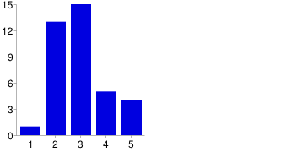

2. Do you think school attendance at secondary schools should be compulsory?
(Yes x No x I don´t know)

3. Do you think students should choose subjects of their study?
(Yes x No x I don´t know)

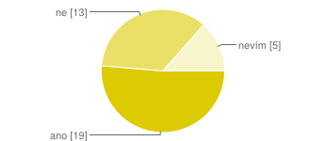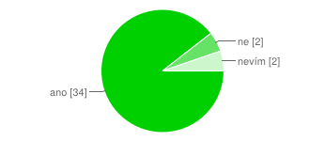

4. Do you think students should attend lessons only when they want?
(Yes x No x I don´t know)

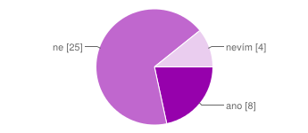
5. Would you like to study abroad? (1 = Yes, absolutely…… 5 = Not at all)

6. Do you think that student abroad get better education?
(1 = Yes, absolutely…… 5 Not at all, )

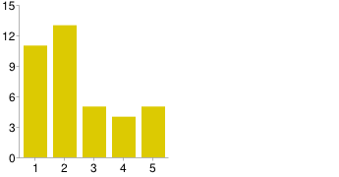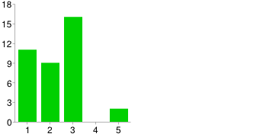

7. Do you think private schools are better than public schools?
(Yes x No x Sometimes yes, sometimes no x I dono´t know)

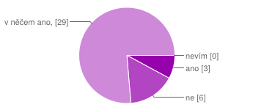

II. QUESTIONS ABOUT SCHOOL

8. Rate the school you are studying at (1 = excellent….. 5 = very bad)
9. Rate the school environment (building, classroms, labs, gyms)
(1 = excellent….. 5 = very bad)

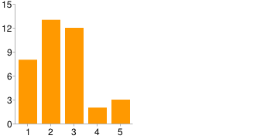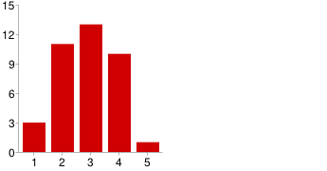

10. Rate the attitude of teachers towards students at your school
11. Rate the attitude of students towards teachers at your school
(1 = excellent….. 5 = very bad)

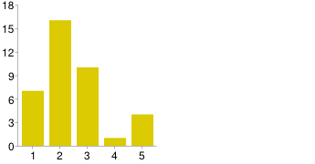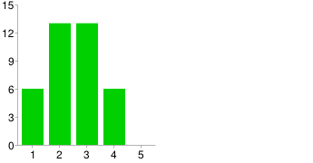
12. Rate the difficultness of the study at your school (1 = very easy….5 very difficult)

13. Do you consider yourself a good student? (1 = Yes, absolutely…… 5 = Not at all)

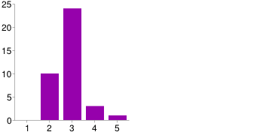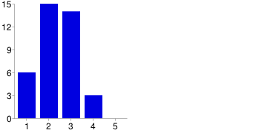

14. Are you going to continue with studies at a university?
(1 = Yes, absolutely…… 5 = Not at all)

15. Is the education you get at your school useful for your future job?
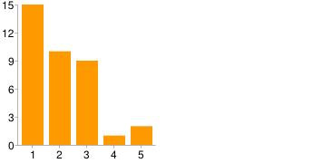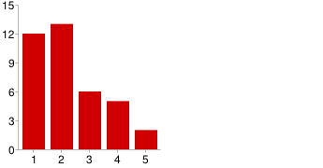

16. What do you like about your school?

The numbers of answers was: European projects (16), pratical training (15), atmosphere at school (15), vocational lessons (10), school environment (8), general lessons (4), everything (4), other (2), nothing (2), sport activities (1),

17. What do you miss at your school?

The numbers of answers was: More excursions (21), better school environment (17), more sport activities (13), better atmosphere at school (10), better vocational lessons (9), more European projects (9), better practical training (8), better general lessons (5).

18. Would you prefer school uniforms at school? (Yes x No x I don´t know)
19. When do you think the lessons at your school should start and end?

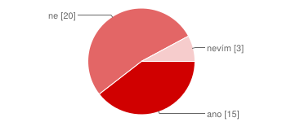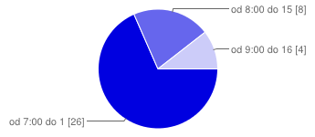

III. SCHOOL SUBJECTS

In this part we carried out a research about school subjects – Czech language, English language, German language, accounting, economy, math, typewriting, ICT, other general lessons and other vocational lessons. All the subjects had two questions:

a) rate the difficultness of ….
b) rate the popularity of ……

We wanted to know which subject are easy and which are difficult and whether the popularity of a subject depends on its difficultness. We found out that for the students the easiest subjects are the lessons of ICT or typewriting, but these subjects are not the most popular for all the students. When we compared the lessons of English, German and Russian language, we found out that the most popular language lessons are English.

CONCLUSIONS AND SUGGESTIONS

From the results of the survey we can see that the Czech educational system is not bad, most students evaluated it as average with the mark 2,9. Many students want to continue their studies at universities here or abroad. A very interesting thing is that most students would like to choose the subjects of study. When we compared private and public schools, there was only little difference.

In the second part we asked the students about the school. The average mark is 2,45 and this means that the students find the school better than an average Czech school. School environment could be better, however, the relationships between teachers and students are quite good. The students appreciate particularly: European projects, practical training and the school atmosphere. On the other hand students would like to have more excursions and school trips, better school environment and more sport activities. We also asked about school uniforms, but only 40% would like to introduce them at school. As for beginning of lessons, most students do not mind of school starts very early. Most students find themselves rather a good or at least an average student.

The last part of the questionnaire was dealing with school subjects in our school. We wanted to know how difficult they are for students and which lessons they like or do not like. The easiest subjects were typewriting and information technologies, the most difficult were accounting and other vocational subjects. The most popular subjects among the students are information technologies, general subjects (geography, history etc.), typewriting or English language and the least popular is German language. Comparing the results of those two questions we realised that the easier a subject seems to students the more popular among them is.

For an ideal European school we suggest to do the following things:
- allow the students to choose the subjects of their study more
- allow students to have more practical training
- improve the school atmosphere
- organize more sport activities
- allow students to decide about their study more
- decide practical matters Together – headmaster, teachers, students
- follow the students´ interests more
- cooperate with other European schools more

Martin Frolík and the students of Class 2
Obchodní akademie Karviná, s.r.o

